Title

((Abstract text. Maximum length 250 words. Written in the present tense.))

Keywords: ((3–7 keywords, not capitalized, plural, separated by commas, no full stop))

1. Introduction

2. First-Order Heading

2.1. Second-Order Heading

2.1.1. Third-Order Heading
Fourth-Order Heading: ((Text, no numbering))

((Main Text Paragraphs. Please make the first reference to a display item bold (Figure 1). Do not abbreviate Figure, Equation, etc.; display items are always singular, i.e., Figure 1 and 2. Equations are always singular, i.e., Equation 1 and 2, and should be inserted using the Equation Editor, not as graphics, in the main text. Display items and captions should be inserted in-line within the main text))

Figure 1. ((Figure Caption. Note: Please do not combine figure and caption in a textbox or frame.))
Reproduced with permission.^{[Ref.]} Copyright Year, Publisher.

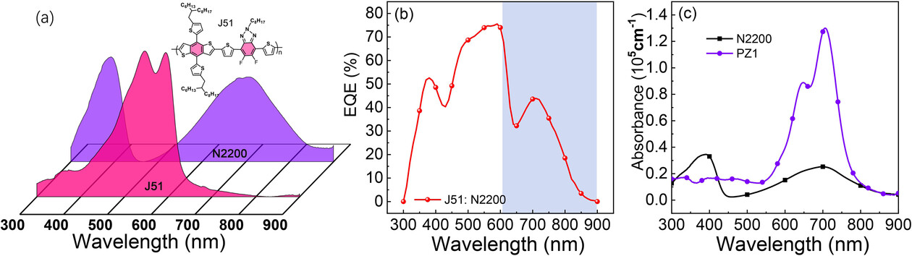
Figure 1. a) Complementary absorption of donor and acceptor in the all-PSCs with J51 as polymer donor and N2200 as polymer acceptor. b) The external quantum efficiency of all-PSCs based on J51:N2200 (w/w, 2:1). c) The absorption coefficients of N2200 and PZ1 in films. Reproduced with permission.^{[29]} Copyright 2016, Wiley-VCH.

Table 1. ((Table Caption. Note: Please do not combine table and caption in a textbox or frame)) Reproduced with permission.^{[Ref.]} Copyright Year, Publisher.

((Equation)) (1)

((References should be superscripted and appear after punctuation.^{[1,2]} Please define all acronyms except IR, UV, NMR, and DNA or similar)

((Number)). Conclusion

References
1. H. Hussein, A. Damdam, L. Ren, et al., “Actuation of Mobile Microbots: A Review,” Advanced Intelligent Systems 5, no. 9 (2023): 2300168. https://doi.org/10.1002/aisy.202300168
2. J. Li, B. Liu, W. Chen, S. Zhang, J. Deng, and Y. Liu, “An Agile 3 Cm-Scale Quadruped Piezoelectric Robot with a Rigid Ring-Shaped Structure,” Advanced Functional Materials (2025): 2422499,
https://doi.org/10.1002/adfm.202422499
3. S. Ronca 2017. “ Chapter 10-Polyethylene.” in Brydson's Plastics Materials. Eighth Ed., edited by M. Gilbert, Oxford: Butterworth Heinemann. ISBN 978-0-323-35824-8.
4. F. C. Bettonvil et al., “Telescope Design for High-Resolution Solar Observations,” in Proceedings of the SPIE Conference Series, vol. 4853 (2003): 306.
5. R. J. Rutten, “Solar Chromosphere Observations and Models,” in The Physics of Chromospheric Plasmas, ed. P. Heinzel, I. Dorotovic, and R. J. Rutten, ASP Conference Series 368 (2007): 27.

Appendix ((delete if not applicable))

